The Seven Levels of Lead Generation
Have you ever thought about all the different areas you generate business from and the effectiveness of each area or level? We have created a chart which we feel shows different levels of lead generation and a way to better understand the “flow” of leads into your business.
Starting with Level One: Broad based internet and email marketing. Many agents pay a service to “drip-email” newsletters or other information to a list of names…or they may pay REALTOR.com or sites like Trulia or Zillow for leads….as you can see from the chart this is the widest base…these activities sometimes generate a lot of cold leads for your business. You just have to understand… your time is valuable and chasing cold internet leads takes up a big chunk of your time.
Level Two has a little less broad base and the leads you get from your personal website or social media may tend to be a little “warmer” lead. These are people who have clicked on your site for a reason…either they know you or want and have a reason to do business with you.
Level Three narrows the leads down even further…Phone-Duty, Open House and Sign Calls are prospective clients who have jumped off the internet train and are willing to get a little more personal and in your face. These leads require you to personally answer the phone or get face to face enabling you to start the relationship building process.
Level Four are people who you know either want to sell or wanted to sell at one time…your goal here is to determine if they still want to sell, and to discover the real reason (or reasons) the property hasn’t sold.
Level Five is your Book of Business and should be where you are generating the highest quality leads for your business, these are coming from people who know, like, and trust you, and have a high percentage close rate. Leads from this source should have a 70% close rate.
Level Six is the most important level if you want to grow your business. What system(s) do you use to stay in constant contact with the leads you generate from each proceeding level? Do you even have a system? If not, you are missing out on a huge portion of your business. You cannot effectively manage a database over 10-12 in your head. Don’t let quality buyers and sellers slip through the cracks and off to another agent due to your lack of a database management system.
Level Seven is the transaction level… Don’t forget the reticular activator! ( ). While in a transaction is the best time to ask your clients for referrals. This is the period clients are the most “in-tune” with real estate and others who are also in the process.
I hope you will be able to use this info to effectively and efficiently funnel new quality leads into your business and to generate a higher income for the months ahead!
Have you written a hand written note today?

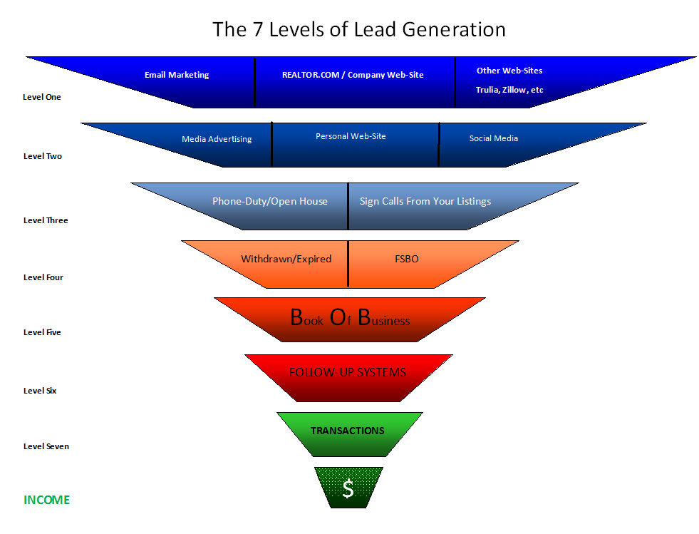
Eddie Brown / ICU-Coaching ©2013

